Security Assessment Report
Prepared for: Management & IT Team
Prepared by: Security Team
Date: November 11, 2025
Assessment Target: Host 172.20.10.2 (metasploitable.localdomain)

1. Executive Summary
A security assessment of the server metasploitable.localdomain revealed a critically vulnerable state, requiring immediate attention. The system is running numerous outdated and insecure services, making it highly susceptible to a complete compromise. A key finding is a critical backdoor in the FTP service that allows an attacker to gain full control of the system with minimal effort. Furthermore, weak encryption, plaintext passwords, and other severe vulnerabilities were identified across multiple services.
It is strongly recommended to immediately isolate this server from the network. Long-term mitigation requires a comprehensive plan to decommission or rebuild this system with updated software, strict access controls, and the removal of non-essential services to protect organizational assets.

2. Detailed Findings & Attack Path Analysis
The assessment utilized network scanning (Nmap) and vulnerability scanning (OpenVAS) to identify security weaknesses.

2.1. Critical Vulnerabilities
Vulnerability | Service | Port | CVSS (Est.) | Impact
Vsftpd 2.3.4 Backdoor (CVE-2011-2523) | FTP | 21/tcp | Critical (10.0) | Remote Code Execution
UnrealIRCd Backdoor | IRC | 6667/tcp | Critical | Remote Code Execution
Metasploitable Bind Shell | Linux Shell | 1524/tcp | Critical | Remote Root Access
Samba username map script | SMB | 139/445/tcp | High | Remote Code Execution
Outdated & Vulnerable Services (SSH, BIND, MySQL, PostgreSQL) | Multiple | Multiple | High | Various (Priv. Escalation, DoS)

2.2. Illustrated Attack Path
An attacker can easily exploit this system through a clear and documented path, as visualized below: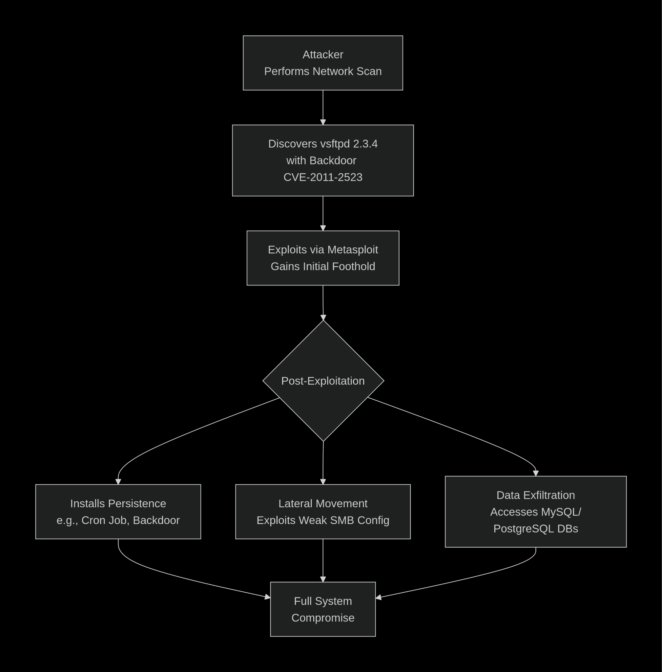

This path demonstrates how the initial vulnerability leads to a complete breach.

3. Recommendations
Prioritize actions based on the criticality of the findings.

Immediate Actions (Within 24-48 Hours)
- Network Isolation: Immediately block all network traffic to and from the host 172.20.10.2 at the firewall. Specifically, ensure TCP port 6200 (the vsftpd backdoor) is blocked.
- Service Shutdown: Stop and disable the vsftpd service and any other non-critical services (e.g., Telnet, rsh, ProFTPD).
- Host Isolation: Take the system offline until it can be properly remediated.

Short-Term Actions (Within 1 Week)
- Patch Management: Apply all available security patches for the underlying operating system (Ubuntu) and all installed software.
- Service Hardening:
  - FTP: Replace vsftpd and ProFTPD with a secure alternative like OpenSSH (SFTP).
  - SMB: Configure Samba to disable guest access and enforce message signing.
  - Databases: Upgrade MySQL and PostgreSQL to supported versions and change default credentials.
  - Remote Access: Disable Telnet, rsh, and rlogin. Use only SSH with key-based authentication.
- System Rebuild: Given the number and severity of issues, the most secure path is to rebuild the server from a known-good base image and re-deploy necessary services in a hardened configuration.

Long-Term Strategic Actions
- Vulnerability Management Program: Implement a regular schedule for automated vulnerability scanning and patch management.
- System Hardening Baseline: Develop and apply a security hardening baseline for all servers (e.g., using CIS Benchmarks).
- Network Segmentation: Segment the network to restrict unnecessary traffic between servers and user segments.
- Verification: After remediation, perform a new vulnerability scan to confirm all identified issues have been resolved.

Appendix A: Tools and Commands Used
- Network Scanning: nmap -sC -sV 172.20.10.2
- Vulnerability Scanning: OpenVAS
- Exploitation Framework: Metasploit (for validation)

